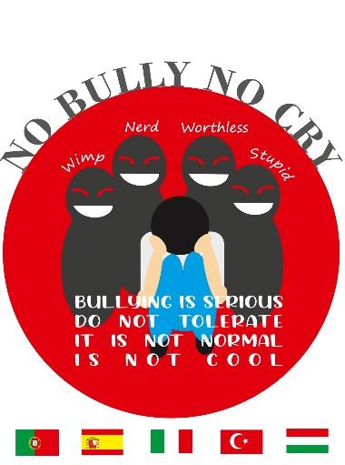
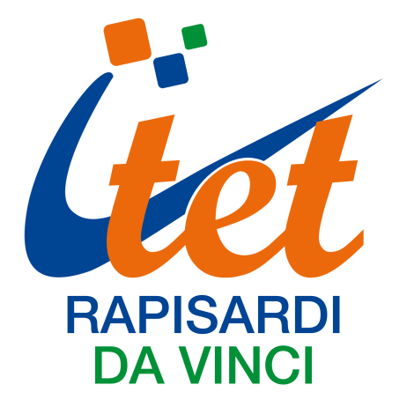

Project title: NO BULLY NO CRY
Project number: 2020-1-HU01-KA229-078661_4

MINUTE OF THE 4th LTTA HELD IN Caltanissetta, Italy at the ITET “Rapisardi Da Vinci”
The 4th LTTA of the Erasmus project “No Bully No Cry” took place in Caltanissetta, Italy, from the 13th to the 17th of March 2023. This short-term exchange of groups of pupils had participants from: AE Nuno de Santa Maria, Tomar, Portugal; Colegio San Isidoro, Granada, Spain; Tasoluk Anadolu Lisesi, Istanbul, Turkey; Nyíregyházi SZC Vásárhelyi Pál Technikum, Nyíregyháza, Hungary; ITET Rapisardi Da Vinci, Caltanissetta, Italy.
Date | 13th - 17th of March 2023
Venue | ITET Rapisardi Da Vinci  V.le R. Margherita, 27  93100 Caltanissetta, Italy
Activity title | Exhibition of posters and other products of the project Take a stand together'' workshop
Activity type | Short-term exchanges of groups of pupils
Project Objectives | - Provide a chance to develop an intercultural understanding of bullying for the staff and the pupils thus tackling early school leaving and promoting equity.  - Create an inclusive environment and give direction and guidance to school authorities and school personnel in preventing and combating school-oriented bullying behaviour among its pupils and in coping with any negative effect within school of bullying manner that takes place anywhere.  - Establish awareness and solutions to this significant and non-negligible problem firstly starting from students in our schools-neighbourhoods and the European community by disseminating the results.  - Teach students about the appropriate use of social media so that they won't come across online bullying.  - Let the pupils gain positive communication skills as this skill will create a more positive environment where bullying is less likely to occur.  - Increase experience and understanding about such issues like online bullying,verbal bullying,social bullying and physical bullying besides providing the students and staff with a skill to understand and apply new bullying detection and prevention techniques.  - Reduce possible violence arising from bullying among students  - Provide a direct access to international approaches to prevent bullying at a European extent  - Provide the students with a better cultural and language understanding
Attendance
Participants from Agrupamento de Escolas Nuno de Santa Maria- Tomar, Portugal | Teachers:  Henriques Marta  Duarte Silvia  Students:  Antunes Joana  Ramalho Danica  António Miguel  Antunes Miguel
Participants from Colegio San Isidoro- Granada, Spain | Teachers:  Liceras Jiménez Ana  José Manuel Manzano Jiménez  Students:  Milena Bianchi Sofia  Manzano Murillo Carla  Quintanilla Martín Candela  Gómez Rodríguez Paula
Participants from Tasoluk Anadolu Lisesi- Istanbul, Turkey | Teachers:  Halil Yilmaz  Yasin Sevinç  Students:  Abdullah Çaylak  Ali Şahin  Furkan Aydemir  Yusuf Mert Alici
Participants from Nyíregyházi SZC Vásárhelyi Pál Technikum, Nyíregyháza, Hungary | Teachers:  Fabók Judit  Csorbáné Kurucz Mária  Students:  Nemes Martina  Tóth Adél  Lengyel Réka  Hibján Eszter
ITET Rapisardi Da Vinci, Caltanissetta, Italy | Teachers:  Trombello Rosaria  Giammusso Laura Pia  Students:  Di Francesco Gabriele  Kardos Stela Denisa  Carli Lorenzo  Lana Giulia  Progno Monteleone Mattia  Costanza Alice  Vullo Samuele Karol  Puzzangara Giorgio Emanuele  Capitano Dalila Anna  Caio Filippo Pio  Fonti Siria Maria  Giordano Carlo Marco  Riggi Cristal Rita  Filippazzo Giovanni  Di Salvo Victoria  Ippolito Daniele

1st Day

We started our week together welcoming the participants at our school, in the main building, where the exhibition of the posters, prepared in the previous mobility in Granada, was organized in an innovative way. Posters were collected and shown on a digital screen in the school hall so that everyone entered the school could see them and think about the topic of the project. Then our partners were led to the aula magna where our headmistress greeted them. All of us introduced to the rest of the group and then each member was gifted with a bag with the logo of the project. After this first moment of getting to know, our Spanish coordinator shared presented the results of the survey on bullying that was carried out by the Spanish team using Google Forms and that was answered by the members of the project. The coordinator of the project showed also the results of a survey done only among Hungarian students. A break with typical Sicilian food was offered before heading to the Town Hall. There we were welcomed by the mayor of Caltanissetta, Mr Gambino, to whom it was explained what our project is about. He showed great interest on it and after wishing us to spend a good week together, we were shown around. We could visit the historical building ere the town hall has its offices and the main theater of the town.
After lunch, a guide walked us in the city centre, explaining the origins of the town and its history, visiting the oldest part of the town and the main squares and churches and the cathedral.

2nd Day:

The second day started with two workshops organized by “Casa Famiglia Rosetta”, an association headquartered in Caltanissetta, that was born in the early eighties to meet local needs in the field of health and psycho-social services policy and whose main aim is to give concrete answers to those who suffer marginalization and social exclusion. This is the reason because last February they launched the "Stop bullying now" initiative, in order to give support to those who have suffered or participated in episodes of bullying or cyberbullying. We were hosted at the youth counseling center where 3 specialists helped students and teachers to deal with the aggressive attitude and the emotions which arouse when dealing with these events.
Soon after lunch we had a cultural trip to Valle dei Templi (Valley of the Temples), an archaeological site in Agrigento (ancient Greek Akragas), on the southern coast of Sicily. It is one of the most outstanding examples of ancient Greek art and architecture, and is one of the main attractions of Sicily. An official guide walked us though the seven temples, explaining their names, their origins and throwing us back to the Greek era. After the visit of the valley, we went to San Leone a nearby town on the coast.

3rd Day

On the third day we moved to the second building of our school where students were involved in sport activities organized by one of the school PE teachers. The purpose was to help students to understand how sport can prevent violence and bullying among teens by engaging them in sports activities as an alternative to delinquency and bullying. Sport represent fun, friendship, discipline, achievement and tolerance, by solving problems in a peaceful manner and contributing to a healthy society. Meanwhile the teachers were shown some of the technological projects, thought and developed by some students attending the IT course. They could ask questions to the students and their teachers and they were able to see how these inventions work. After the break, the project coordinator presented some of the activities related to the project: a video on bullying behavoiur, a video on bullying interviews, a leaftlet. The morning ended with an open air activity. Students were given different pieces of coloured chalk and they were invited to draw and write words and images related to bullying on the ground. Students had great fun and they used their imagination in a creative way.
After lunch, we met two policemen working for the department of Postal and Communications Police), one of the departments of the Polizia di Stato, the State Police of Italy. Its functions include the investigation of cybercrime.
At first they talked about the laws to fight cyberbullying and bullying in Italy, then they presented some very shocking cases of victims, focusing on the right and wrong things to do when dealing with cyberbullying..
In the evening we had a “giro pizza”. It was a way for our foreign guests to taste delicious pizzas in a very picturesque restaurant.

4th Day

This day was dedicated to the cultural and touristical sights of the capital town of Sicily, Palermo. As soon as we arrived in Palermo, we met our guide who led us to Palazzo dei Normanni, the seat of the Sicilian government and UNESCO world heritage site. There we could visit Cappella Palatina, an amazing chapel covered in mosaics and being the example of the integration of different cultures.
After living Palazzo dei Normanni, our guide walked us through the most fascinating places in Palermo: the Cathedral, Quattro Canti, Piazza della Vergogna ( actually the real name is Piazza Pretoria, but since there lots of naked statues it was called “Shame square”), just mention a few.
After lunch, we walked along Via Maqueda to reach Teatro Massimo, the second biggest theatre in Europe.
Before driving back to Caltanissetta, we stopped at Cefalù, a characteristic fishing village which dates back to the Normans. We arrived at sunset and it was the perfect time to take wonderful pictures on the beach.

5th Day

The first part of the last morning was dedicated to the staff meeting for teachers and to a lesson on Italian gestures for students. During the staff meeting the coordinator checked the list of activities to be completed from the previous mobilities and what to do for the last one in Istanbul.
The break was a moment of sharing food and traditions thanks to the Italian students who brought typical Sicilian homemade food. It was a moment of joy, enriched by dances and songs.
We closed our day with the certificate ceremony and we signed the attendance sheet and said goodbye.

